**ADVANCE EXCEL ASSIGNMENT - 9**

**Q1. What are the different margins options and do we adjust the margins of the excel worksheet?**

**Ans.** In Microsoft Excel, margins refer to the blank spaces at the top, bottom, left, and right of a worksheet. Adjusting margins allows you to control the layout and spacing when printing your Excel worksheet. Here are the different margin options and how you can adjust them:

**Different Margins Options:**

1. **Top Margin:** The space at the top of each printed page.
2. **Bottom Margin:** The space at the bottom of each printed page.
3. **Left Margin:** The space at the left side of each printed page.
4. **Right Margin:** The space at the right side of each printed page.
5. **Header Margin:** The space between the top of the printed page and the header.
6. **Footer Margin:** The space between the bottom of the printed page and the footer.

**How to Adjust Margins in Excel:**

1. **Page Layout View:** Go to the "View" tab on the ribbon. Click on "Page Layout" to switch to Page Layout view.
2. **Page Layout Tab:** In Page Layout view, go to the "Page Layout" tab on the ribbon.
3. **Margins Options:** Click on the "Margins" dropdown in the Page Layout tab. You will see options such as "Normal," "Wide," "Narrow," "Custom Margins," and "More Options."
4. **Custom Margins:** Select "Custom Margins" if you want to specify margins manually. In the Page Setup dialog box, you can enter values for Top, Bottom, Left, and Right margins.
5. **Print Preview:** To see how your changes affect the printed page, go to the "File" tab and choose "Print" or use the shortcut **Ctrl + P**. The Print Preview will display the layout, including margins.
6. **Adjusting in Normal View:** You can also adjust margins in Normal view by going to the "Page Layout" tab and using the "Margins" dropdown. Click on the "Custom Margins" option to set specific values.
7. **Drag and Drop (Manual Adjustment):** In Page Layout view, you can manually adjust margins by clicking and dragging the margin indicators on the ruler.
8. **Page Setup Dialog Box:** You can access the Page Setup dialog box by clicking the small arrow in the bottom-right corner of the Page Setup group on the Page Layout tab.

**Q2. Set a background for your table created.**

**Ans.** Create a table as shown in the image below:

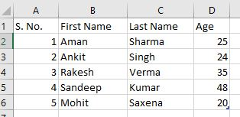

Select the entire range and press **Ctrl + T** to convert it to a table.

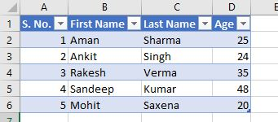

Now, to set a background for a table in Excel. Here are the general steps:

1. Click anywhere in your table.
2. Go to the "Table Design" tab that appears when your table is selected.
3. In the Table Styles group, you can choose different predefined table styles that include background colours.

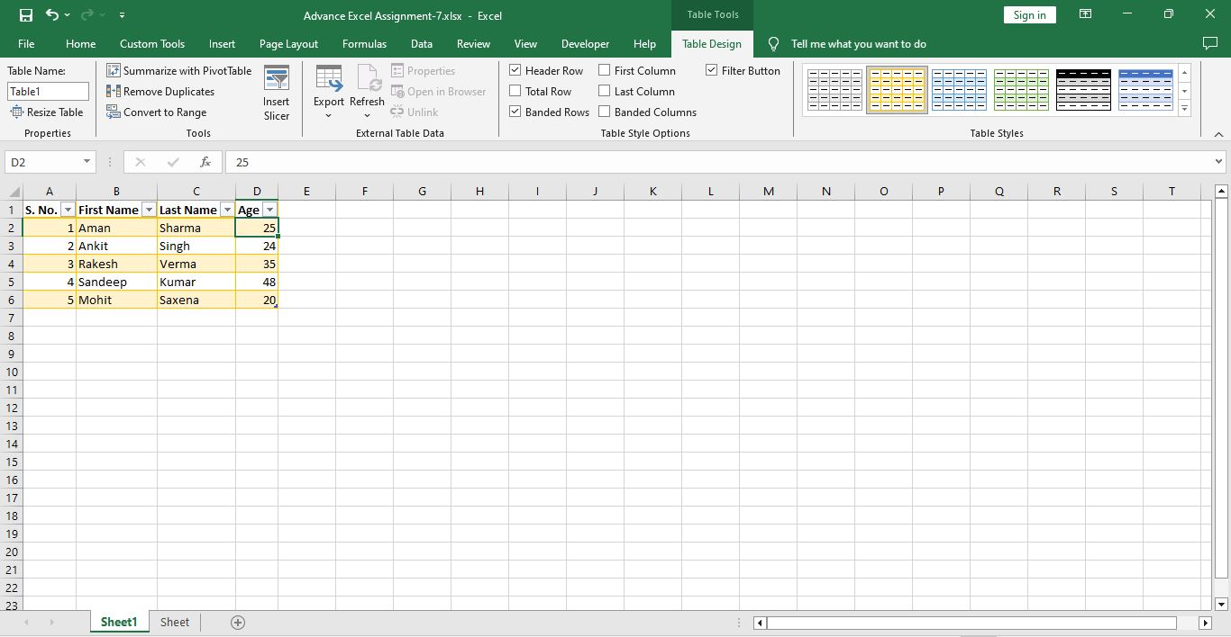

**Q3. What is freeze panes and why do we use freeze panes? Give examples.**

**Ans.** Freeze Panes allows user to lock specific rows or columns in place while scrolling through a worksheet. This feature is particularly useful when working with large datasets where the user wants to keep certain headers or labels visible as you navigate through the data.

**How to Freeze Panes:**

1. **Freezing the Top Row:** Go to the row just below the row you want to freeze (typically, the row containing headers). Click on the "View" tab. Select "Freeze Panes" and choose "Freeze Top Row."

Example: You have a large dataset with column headers, and you want to keep the headers visible while scrolling.

1. **Freezing the First Column:** Go to the column just to the right of the column you want to freeze (typically, the column containing row labels). Click on the "View" tab. Select "Freeze Panes" and choose "Freeze First Column."

Example: You have a wide dataset, and you want to keep the first column (e.g., row labels) visible while scrolling horizontally.

1. **Freezing Both Rows and Columns:** To freeze both rows and columns simultaneously, click on the cell below and to the right of the rows and columns you want to freeze. Click on the "View" tab. Select "Freeze Panes" and choose "Freeze Panes."

Example: You have a large dataset with both row and column headers, and you want to keep both visible while scrolling.

1. **Unfreezing Panes:** To unfreeze panes, go to the "View" tab, select "Freeze Panes," and choose "Unfreeze Panes."

**Q4. What are the different features available within the Freeze Panes command?**

**Ans.** The "Freeze Panes" command in Microsoft Excel offers different options to freeze specific rows or columns, providing users with flexibility in managing their worksheet layouts. Here are the different features available within the "Freeze Panes" command:

1. **Freeze Top Row:** Keeps the top row of the worksheet visible while scrolling down through the data.
2. **Freeze First Column:** Keeps the first column of the worksheet visible while scrolling horizontally through the data.
3. **Freeze Panes:** Allows you to freeze both rows and columns simultaneously.
4. **Unfreeze Panes:** Removes the frozen state, allowing rows and columns to scroll freely.

**Q5. Explain what the different sheet options present in excel are and what they do?**

**Ans.** In Excel, sheets are organized into workbooks, and each workbook can contain multiple sheets. The different sheet options and features in Excel provide a range of functionalities for organizing and managing data. Some key sheet-related options in Excel are:

* **Insert Sheet:** Adds a new sheet to the workbook.
* **Delete Sheet:** Removes the selected sheet from the workbook.
* **Rename Sheet:** Allows user to give a custom name to a sheet.
* **Sheet Tab Color:** Let user change the color of the sheet tab for better organization.
* **Move or Copy Sheet:** Moves or copies a sheet to another location within the same or a different workbook.
* **Protect Sheet:** Restricts changes to the structure and elements of a sheet, such as cells, rows, and columns.
* **Group Sheets:** Allows user to group multiple sheets together for simultaneous formatting or editing.
* **Ungroup Sheets:** Dissolves the group of sheets.
* **Hide Sheet:** Conceals the selected sheet from view.
* **Unhide Sheet:** Reveals a hidden sheet.
* **Zoom Slider:** Adjusts the zoom level for the entire workbook, affecting all sheets.